### **Multiple-Choice Questions (MCQs):**

JavaScript Fundamentals:

What does the typeof operator return when used with typeof 42?

**A) number**

B) string

C) object

D) undefined

Which keyword is used to declare a variable in JavaScript?

A) var

B) int

**C) let**

D) const

What is the result of "5" + 2 in JavaScript?

**A) "52"**

B) 7

C) "7"

D) Error

How do you comment a single line in JavaScript?

**A) // This is a comment**

B) <!-- This is a comment -->

C) /* This is a comment */

D) # This is a comment

Which function is used to display a message in a popup box in JavaScript?

**A) alert()**

B) confirm()

C) prompt()

D) console.log()

What will be the output of console.log(3 === '3') in JavaScript?

A) true

**B) false**

C) undefined

D) Error

How do you declare a function in JavaScript?

**A) function myFunction() {}**

B) def myFunction():

C) void myFunction() {}

D) function = myFunction() {}

What is the correct way to include an external JavaScript file named script.js in an HTML document?

A) <script href="script.js"></script>

**B) <script src="script.js"></script>**

C) <script include="script.js"></script>

D) <script import="script.js"></script>

Which loop is used for iterating over the properties of an object in JavaScript?

A) for loop

B) while loop

C) do-while loop

**D) for...in loop**

What is the result of NaN === NaN in JavaScript?

A) true

**B) false**

C) undefined

D) Error

Bootstrap Basics:

Which CSS framework is Bootstrap built on top of?

A) Sass

**B) Less**

C) CSS

D) None of the above

Which class is used to create a responsive navigation bar in Bootstrap?

A) .navbar-fixed

B) .navbar-responsive

C) .navbar-expand

**D) .navbar**

How do you create a grid layout in Bootstrap?

A) Using <table> tags

B) Using <div> tags with custom CSS

**C) Using .container and .row classes**

D) Using inline CSS styles

Which class is used to create a responsive image in Bootstrap?

**A) .img-fluid**

B) .responsive-img

C) .img-responsive

D) .fluid-image

How do you create a button in Bootstrap with rounded corners?

**A) .btn**

B) .btn-primary

C) .btn-rounded

D) .btn-rounded-corners

Which grid class is used to create a full-width column in Bootstrap?

A) .col-md-12

B) .col-sm-12

C) .col-lg-12

**D) .col-12**

How do you create a modal dialog in Bootstrap?

A) Using <dialog> tags

B) Using <div> tags with custom CSS

**C) Using .modal and .modal-dialog classes**

D) Using JavaScript alert() function

Which class is used to create a dropdown menu in Bootstrap?

A) .dropdown-toggle

**B) .dropdown-menu**

C) .dropdown

D) .drop-menu

How do you create a responsive table in Bootstrap?

A) Using <table> tags with custom CSS

**B) Using .table and .table-responsive classes**

C) Using <div> tags with inline styles

D) Using JavaScript to dynamically adjust table size

Which class is used to create a carousel (image slider) in Bootstrap?

A) .carousel-item

B) .carousel-slide

C) .slider

**D) .carousel**

Answer: D) .carousel

### **Exercise Questions:**

Create a simple JavaScript program that prompts the user to enter two numbers, then displays their sum in an alert box.

**Program:**

<!DOCTYPE html>

<html lang="en">

<head>

    <meta charset="UTF-8">

    <meta name="viewport" content="width=device-width, initial-scale=1.0">

    <title>javascript</title>

</head>

<body>

    <script>

        var num1 = prompt("Enter the first number");

      var num2 = prompt("Enter the second number");

      var sum = parseFloat(num1) + parseFloat(num2);

      alert(`Result = ${num1} + ${num2} = ${sum}`);

    </script>

</body>

</html>

**Output:**

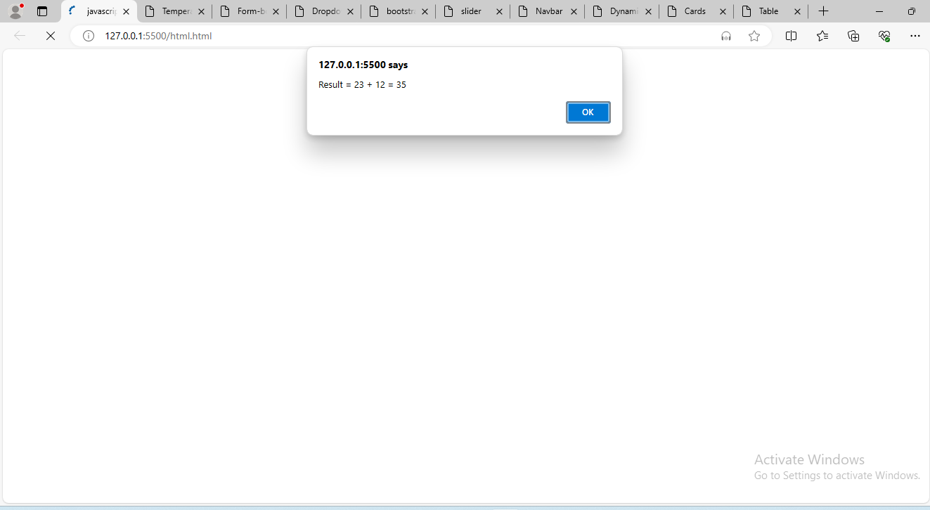

Develop a JavaScript function that takes a Celsius temperature as input and converts it to Fahrenheit, then logs the result to the console.

**Program:**

<!DOCTYPE html>

<html lang="en">

  <head>

    <meta charset="UTF-8" />

    <meta name="viewport" content="width=device-width, initial-scale=1.0" />

    <title>Temperature</title>

  </head>

  <body>

    <script>

      function temperature(celsius) {

        var fahrenheit = (celsius * 9) / 5 + 32;

        document.write(

          celsius +

            " degrees Celsius is equal to " +

            fahrenheit +

            " degrees Fahrenheit."

        );

      }

       temperature(35);

    </script>

  </body>

</html>

**Output:**

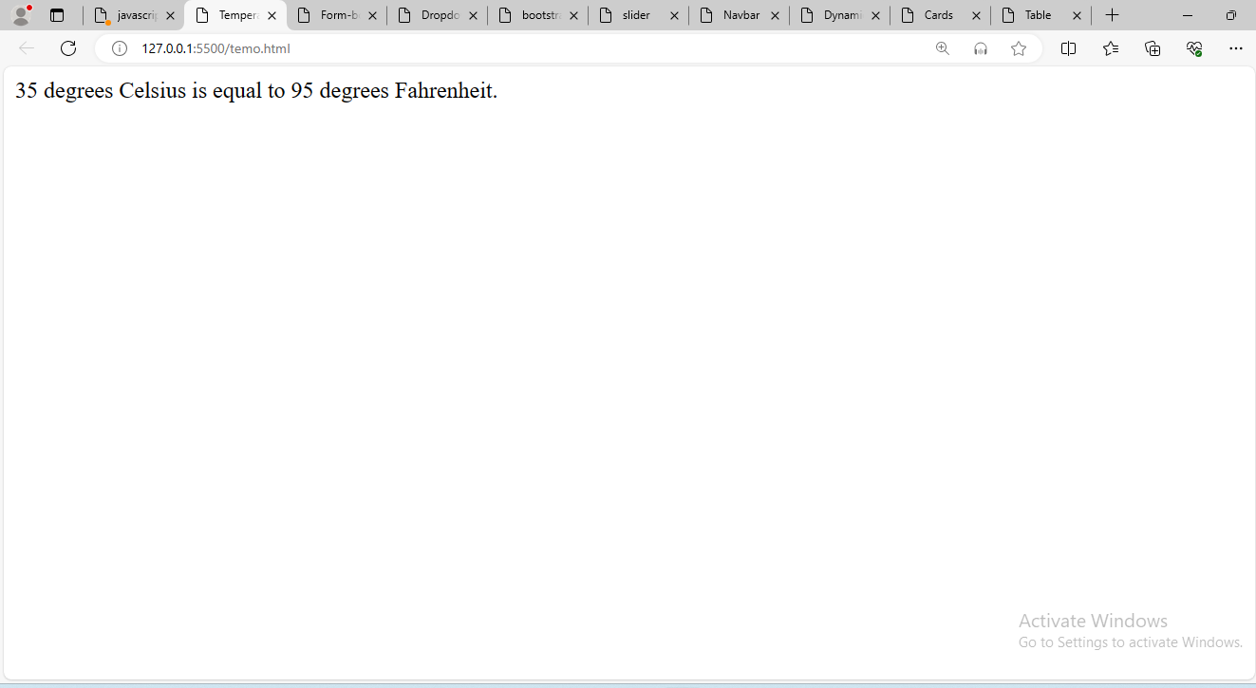

Build a basic Bootstrap webpage with a responsive navigation bar (navbar), a Jumbotron (jumbotron), and a grid layout (container and row).

**Program:**

<!DOCTYPE html>

<html lang="en">

<head>

    <meta charset="UTF-8">

    <meta name="viewport" content="width=device-width, initial-scale=1.0">

    <title>Navbar</title>

    <link href="https://cdn.jsdelivr.net/npm/bootstrap@5.0.2/dist/css/bootstrap.min.css" rel="stylesheet" integrity="sha384-EVSTQN3/azprG1Anm3QDgpJLIm9Nao0Yz1ztcQTwFspd3yD65VohhpuuCOmLASjC" crossorigin="anonymous">

</head>

<body>

    <nav class="navbar navbar-expand-lg navbar-light bg-primary p-3">

        <div class="container-fluid">

          <a class="navbar-brand" style="color: #fff;" href="#">Navbar</a>

          <div class="collapse navbar-collapse" id="navbarNav">

            <ul class="navbar-nav">

              <li class="nav-item">

                <a class="nav-link active" aria-current="page" style="color: #fff;" href="#">Home</a>

              </li>

              <li class="nav-item">

                <a class="nav-link" style="color: #fff;" href="#">Product</a>

              </li>

              <li class="nav-item">

                <a class="nav-link" style="color: #fff;"href="#">Items</a>

              </li>

              <li class="nav-item">

                <a class="nav-link " style="color: #fff;"href="#">Contact</a>

              </li>

            </ul>

          </div>

        </div>

      </nav>

      <div class="jumbotron">

        <div class="container">

          <h1 class="display-4">Hello, world!</h1>

          <p class="lead">

            This is a simple Bootstrap webpage with a responsive navigation bar,

            a Jumbotron, and a grid layout.

          </p>

        </div>

        </div>

        <div class="row m-auto">

                <div class="col-3 mt-3">

                <div class="card" style="width: 18rem;">

                    <img src="image6.jpg" class="card-img-top" alt="...">

                    <div class="card-body">

                      <h5 class="card-title">Card title</h5>

                      <p class="card-text">Some quick example text to build on the card title and make up the bulk of the card's content.</p>

                      <a href="#" class="btn btn-primary">Go somewhere</a>

                    </div>

                  </div>

            </div>

                <div class="col-3 mt-3 ">

                <div class="card" style="width: 18rem;">

                    <img src="image1.webp" class="card-img-top" alt="...">

                    <div class="card-body">

                      <h5 class="card-title">Card title</h5>

                      <p class="card-text">Some quick example text to build on the card title and make up the bulk of the card's content.</p>

                      <a href="#" class="btn btn-primary">Go somewhere</a>

                    </div>

                  </div>

            </div>

                <div class="col-3 mt-3 ">

                <div class="card" style="width: 18rem;">

                    <img src="image7.jpg" class="card-img-top" alt="...">

                    <div class="card-body">

                      <h5 class="card-title">Card title</h5>

                      <p class="card-text">Some quick example text to build on the card title and make up the bulk of the card's content.</p>

                      <a href="#" class="btn btn-primary">Go somewhere</a>

                    </div>

                  </div>

            </div>

                <div class="col-3 mt-3">

                <div class="card" style="width: 18rem;">

                    <img src="image3.avif" class="card-img-top" alt="...">

                    <div class="card-body">

                      <h5 class="card-title">Card title</h5>

                      <p class="card-text">Some quick example text to build on the card title and make up the bulk of the card's content.</p>

                      <a href="#" class="btn btn-primary">Go somewhere</a>

                    </div>

                  </div>

            </div>

                <div class="col-3 mt-3 ">

                <div class="card" style="width: 18rem;">

                    <img src="image4.jpg" class="card-img-top" alt="...">

                    <div class="card-body">

                      <h5 class="card-title">Card title</h5>

                      <p class="card-text">Some quick example text to build on the card title and make up the bulk of the card's content.</p>

                      <a href="#" class="btn btn-primary">Go somewhere</a>

                    </div>

                  </div>

            </div>

            <div class="col-3 mt-3">

                <div class="card" style="width: 18rem;">

                    <img src="image5.jpg" class="card-img-top" alt="...">

                    <div class="card-body">

                      <h5 class="card-title">Card title</h5>

                      <p class="card-text">Some quick example text to build on the card title and make up the bulk of the card's content.</p>

                      <a href="#" class="btn btn-primary">Go somewhere</a>

                    </div>

                  </div>

            </div>

        </div>

</body>

</html>

**Output:**

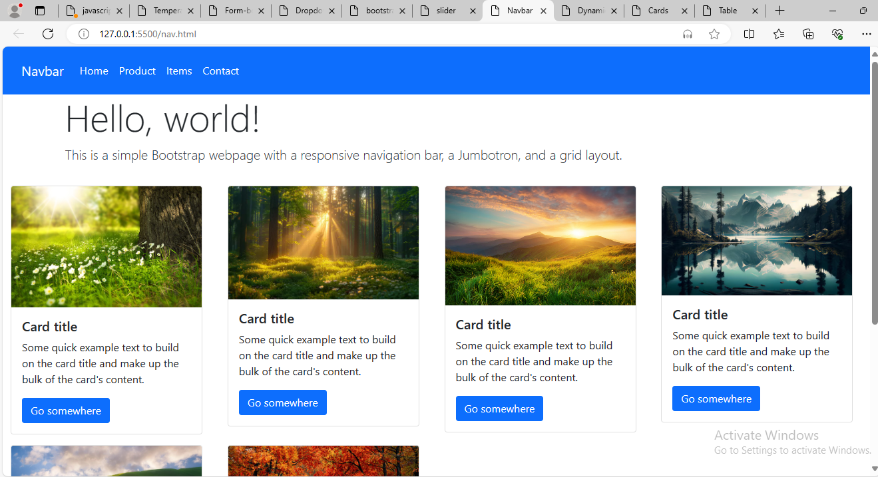

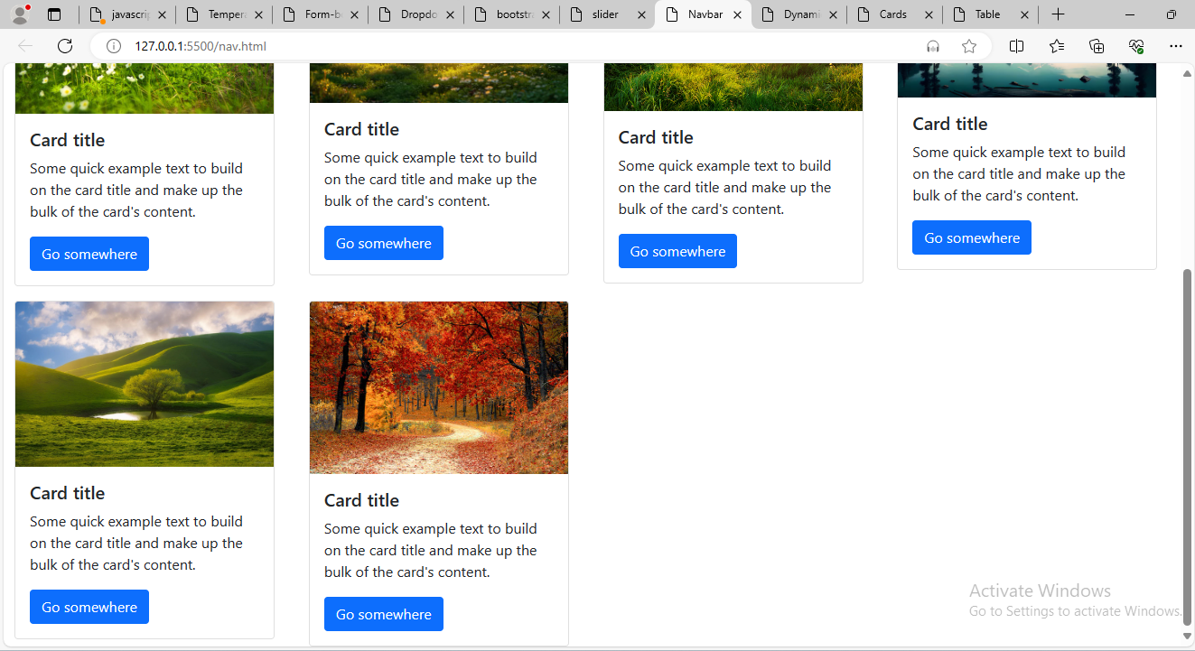

Implement a Bootstrap form with text input fields and a submit button, then use JavaScript to display the entered values in an alert box upon submission.

**Program:**

<!DOCTYPE html>

<html lang="en">

  <head>

    <meta charset="UTF-8" />

    <meta name="viewport" content="width=device-width, initial-scale=1.0" />

    <link

      href="https://cdn.jsdelivr.net/npm/bootstrap@5.0.2/dist/css/bootstrap.min.css"

      rel="stylesheet"

      integrity="sha384-EVSTQN3/azprG1Anm3QDgpJLIm9Nao0Yz1ztcQTwFspd3yD65VohhpuuCOmLASjC"

      crossorigin="anonymous"

    />

    <script

      src="https://cdn.jsdelivr.net/npm/@popperjs/core@2.9.2/dist/umd/popper.min.js"

      integrity="sha384-IQsoLXl5PILFhosVNubq5LC7Qb9DXgDA9i+tQ8Zj3iwWAwPtgFTxbJ8NT4GN1R8p"

      crossorigin="anonymous"

    ></script>

    <script

      src="https://cdn.jsdelivr.net/npm/bootstrap@5.0.2/dist/js/bootstrap.min.js"

      integrity="sha384-cVKIPhGWiC2Al4u+LWgxfKTRIcfu0JTxR+EQDz/bgldoEyl4H0zUF0QKbrJ0EcQF"

      crossorigin="anonymous"

    ></script>

    <link rel="stylesheet" href="form.css" />

    <title>Form-bootstrap</title>

  </head>

  <body>

    <div class="container">

      <div class="row">

        <div class="col-md-12">

          <div class="form-container form-data">

            <form id="loginform" class="p-5 shadow p-3 mb-5 rounded">

              <div class="form-group">

                <label for="uname" class="form-label">User name</label>

                <input

                  type="text"

                  class="form-control"

                  id="uname"

                  name="uname"

                  placeholder="Enter the username"

                />

              </div>

              <div class="form-group">

                <label for="email" class="form-label">email</label>

                <input

                  type="email"

                  class="form-control"

                  id="email"

                  name="email"

                  placeholder="Enter the email"

                />

              </div>

              <div class="form-group">

                <label for="pwd" class="form-label">Password</label>

                <input

                  type="password"

                  class="form-control"

                  id="pwd"

                  name="pwd"

                  placeholder="Enter the password"

                />

              </div>

              <div class="col-6">

                <button type="submit" class="btn btn-primary mt-3">

                  login!

                </button>

              </div>

            </form>

          </div>

        </div>

      </div>

    </div>

    <script>

        document

  .getElementById("loginform")

  .addEventListener("submit", function (event) {

    event.preventDefault();

    var name = document.getElementById("uname").value;

    var email = document.getElementById("email").value;

    var pwd = document.getElementById("pwd").value;

    var alertMessage =

      "Name: " + name + "\nEmail: " + email + "\nPassword: " + pwd;

    alert(alertMessage);

  });

    </script>

  </body>

</html>

**Output:**

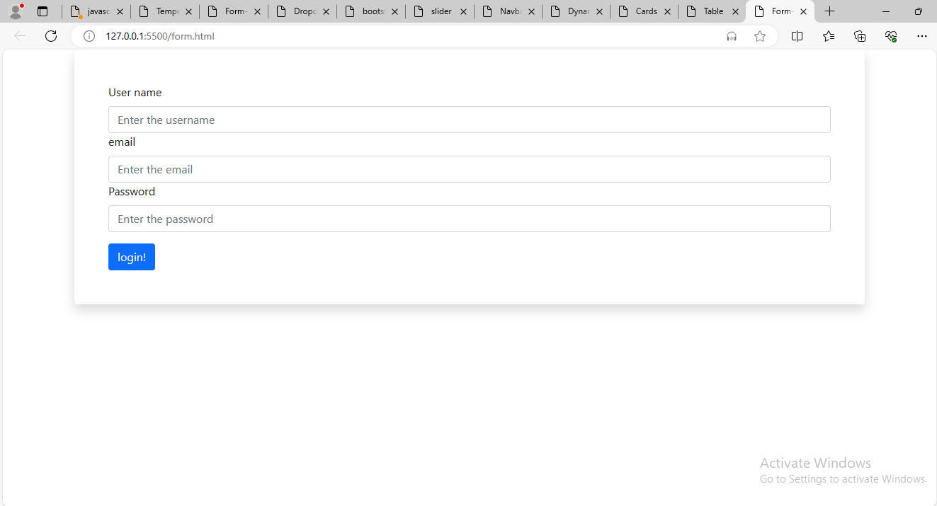

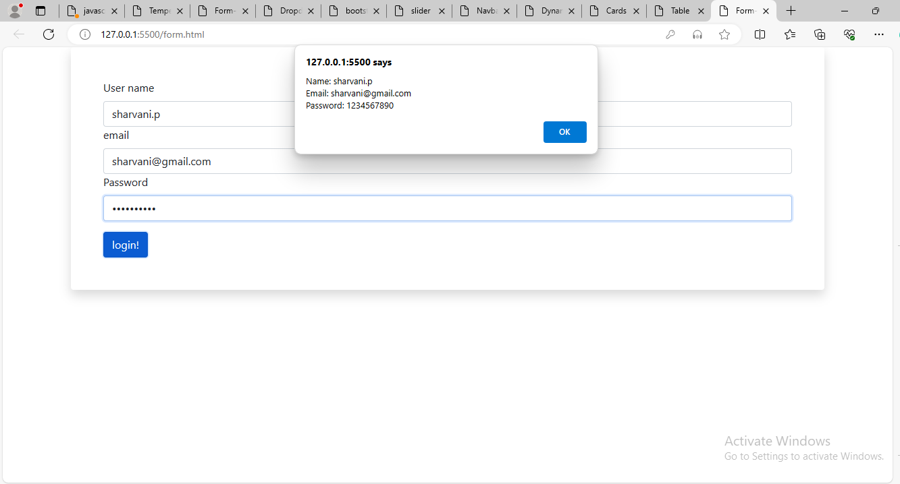

Create a Bootstrap modal dialog that opens when a button is clicked, displaying a message or additional content.

**Program:**

<!DOCTYPE html>

<html lang="en">

  <head>

    <meta charset="UTF-8" />

    <meta name="viewport" content="width=device-width, initial-scale=1.0" />

    <title>bootstrap</title>

    <link

      rel="stylesheet"

      href="https://stackpath.bootstrapcdn.com/bootstrap/4.5.2/css/bootstrap.min.css"

    />

    <script src="https://code.jquery.com/jquery-3.5.1.slim.min.js"></script>

    <script src="https://cdn.jsdelivr.net/npm/@popperjs/core@2.5.4/dist/umd/popper.min.js"></script>

    <script src="https://stackpath.bootstrapcdn.com/bootstrap/4.5.2/js/bootstrap.min.js"></script>

    <link rel="stylesheet" href="dialog.css" />

  </head>

  <body>

    <button

      type="button"

      class="btn btn-info"

      data-toggle="modal"

      data-target="#exampleModal"

    >

       Bootstrap Dialog box

    </button>

    <div

      class="modal fade"

      id="exampleModal"

      tabindex="-1"

      role="dialog"

      aria-labelledby="exampleModalLabel"

      aria-hidden="true"

    >

      <div class="modal-dialog" role="document">

        <div class="modal-content">

          <div class="modal-header">

            <h5 class="modal-title" id="exampleModalLabel">

             dialog box

            </h5>

            <button

              type="button"

              class="close"

              data-dismiss="modal"

              aria-label="Close"

            >

              <span aria-hidden="true">&times;</span>

            </button>

          </div>

          <div class="modal-body">

            <p>

              Lorem ipsum dolor sit amet consectetur adipisicing elit. Fugit nam

              corporis nihil perspiciatis voluptatum! Cupiditate maiores aut

              deleniti quidem fugit rem, nemo veniam, temporibus, corporis ullam

              architecto facilis quasi maxime. Lorem, ipsum dolor sit amet consectetur adipisicing elit. Iure, deleniti sint! Odio molestiae assumenda ab accusamus perspiciatis autem nobis accusantium pariatur totam modi dolor, exercitationem fugit atque, explicabo ullam deleniti!

              Lorem ipsum dolor, sit amet consectetur adipisicing elit. Et ad, laudantium a repellat esse aspernatur quaerat commodi ducimus. Doloremque debitis dolore amet voluptate, aliquam dolor! Dolorum earum quo libero molestias?

            </p>

          </div>

          <div class="modal-footer">

            <button

              type="button"

              class="btn btn-secondary"

              data-dismiss="modal"

            >

              Close

            </button>

            <button type="button" class="btn btn-primary" data-dismiss="modal">

              save Changes

            </button>

          </div>

        </div>

      </div>

    </div>

  </body>

</html>

**Output:**

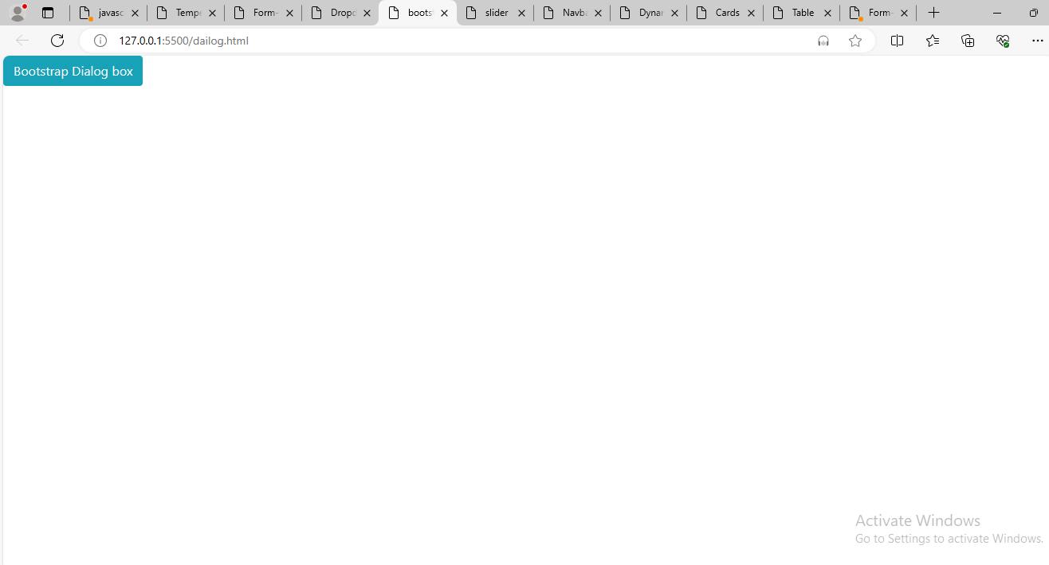

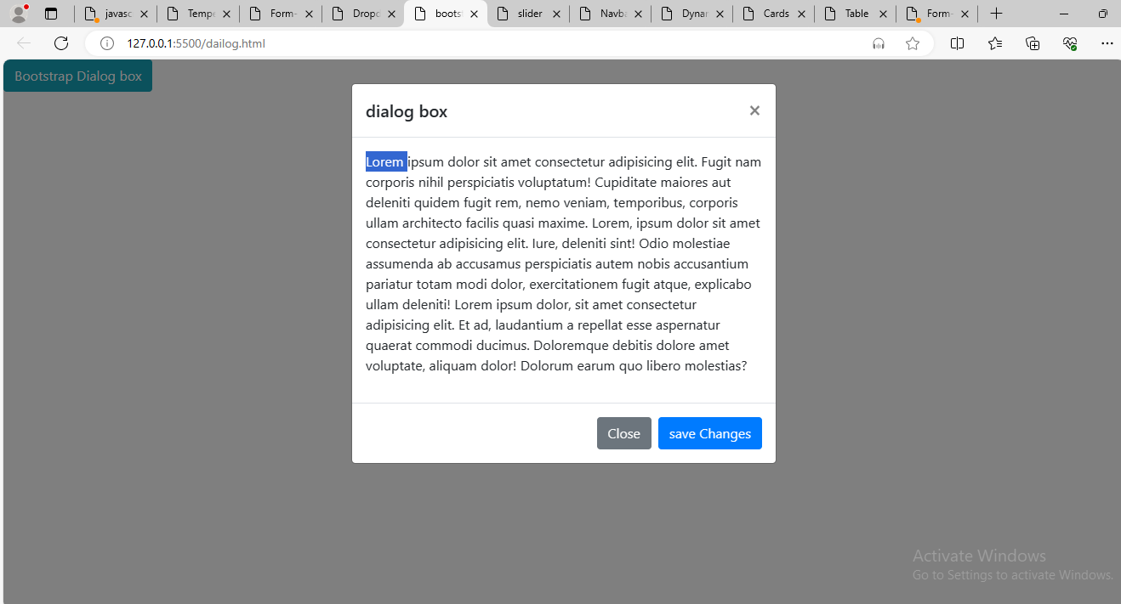

Design a Bootstrap card layout (card) with multiple cards displaying images and text content.

**Program:**

<!DOCTYPE html>

<html lang="en">

  <head>

    <meta charset="UTF-8" />

    <meta name="viewport" content="width=device-width, initial-scale=1.0" />

    <link

      href="https://cdn.jsdelivr.net/npm/bootstrap@5.3.3/dist/css/bootstrap.min.css"

      rel="stylesheet"

      integrity="sha384-QWTKZyjpPEjISv5WaRU9OFeRpok6YctnYmDr5pNlyT2bRjXh0JMhjY6hW+ALEwIH"

      crossorigin="anonymous"

    />

    <link rel="stylesheet" href="bootsrap-cards.css" />

    <title>Cards</title>

  </head>

  <body>

    <div class="row m-auto">

      <div class="col-3 mt-3 transition">

        <div class="card shadow p-3 mb-5 bg-body rounded" style="width: 18rem">

          <img src="images/image11.webp" class="card-img-top" alt="..." height="300px" />

          <div class="card-body">

            <h5 class="card-title">Card title</h5>

            <p class="card-text">

              Some quick example text to build on the card title and make up the

              bulk of the card's content.

            </p>

            <a href="#" class="btn btn-primary">Click Here</a>

          </div>

        </div>

      </div>

      <div class="col-3 mt-3 transition">

        <div class="card shadow p-3 mb-5 bg-body rounded" style="width: 18rem">

          <img src="images/image10.avif" class="card-img-top" alt="..." height="300px" />

          <div class="card-body">

            <h5 class="card-title">Card title</h5>

            <p class="card-text">

              Some quick example text to build on the card title and make up the

              bulk of the card's content.

            </p>

            <a href="#" class="btn btn-primary">Click Here</a>

          </div>

        </div>

      </div>

      <div class="col-3 mt-3 transition">

        <div class="card shadow p-3 mb-5 bg-body rounded" style="width: 18rem">

          <img src="images/image9.avif" class="card-img-top" alt="..." height="300px" />

          <div class="card-body">

            <h5 class="card-title">Card title</h5>

            <p class="card-text">

              Some quick example text to build on the card title and make up the

              bulk of the card's content.

            </p>

            <a href="#" class="btn btn-primary">Click Here</a>

          </div>

        </div>

      </div>

      <div class="col-3 mt-3 transition">

        <div class="card shadow p-3 mb-5 bg-body rounded" style="width: 18rem">

          <img src="images/image8.jpg" class="card-img-top" alt="..." height="300px" />

          <div class="card-body">

            <h5 class="card-title">Card title</h5>

            <p class="card-text">

              Some quick example text to build on the card title and make up the

              bulk of the card's content.

            </p>

            <a href="#" class="btn btn-primary">Click Here</a>

          </div>

        </div>

      </div>

      <div class="col-3 mt-3 transition">

        <div class="card shadow p-3 mb-5 bg-body rounded" style="width: 18rem">

          <img src="images/image7.jpg" class="card-img-top" alt="..." height="300px" />

          <div class="card-body">

            <h5 class="card-title">Card title</h5>

            <p class="card-text">

              Some quick example text to build on the card title and make up the

              bulk of the card's content.

            </p>

            <a href="#" class="btn btn-primary">Click Here</a>

          </div>

        </div>

      </div>

      <div class="col-3 mt-3 transition">

        <div class="card shadow p-3 mb-5 bg-body rounded" style="width: 18rem">

          <img src="images/image6.jpg" class="card-img-top" alt="..." height="300px" />

          <div class="card-body">

            <h5 class="card-title">Card title</h5>

            <p class="card-text">

              Some quick example text to build on the card title and make up the

              bulk of the card's content.

            </p>

            <a href="#" class="btn btn-primary">Click Here</a>

          </div>

        </div>

      </div>

      <div class="col-3 mt-3 transition">

        <div class="card shadow p-3 mb-5 bg-body rounded" style="width: 18rem">

          <img src="images/image5.png" class="card-img-top" alt="..." height="300px" />

          <div class="card-body">

            <h5 class="card-title">Card title</h5>

            <p class="card-text">

              Some quick example text to build on the card title and make up the

              bulk of the card's content.

            </p>

            <a href="#" class="btn btn-primary">Click Here</a>

          </div>

        </div>

      </div>

      <div class="col-3 mt-3 transition">

        <div class="card shadow p-3 mb-5 bg-body rounded" style="width: 18rem">

          <img src="images/image4.jpg" class="card-img-top" alt="..." height="300px" />

          <div class="card-body">

            <h5 class="card-title">Card title</h5>

            <p class="card-text">

              Some quick example text to build on the card title and make up the

              bulk of the card's content.

            </p>

            <a href="#" class="btn btn-primary">Click Here</a>

          </div>

        </div>

      </div>

      <div class="col-3 mt-3 transition">

        <div class="card shadow p-3 mb-5 bg-body rounded" style="width: 18rem">

          <img src="images/image3.webp" class="card-img-top" alt="..." height="300px" />

          <div class="card-body">

            <h5 class="card-title">Card title</h5>

            <p class="card-text">

              Some quick example text to build on the card title and make up the

              bulk of the card's content.

            </p>

            <a href="#" class="btn btn-primary">Click Here</a>

          </div>

        </div>

      </div>

      <div class="col-3 mt-3 transition">

        <div class="card shadow p-3 mb-5 bg-body rounded" style="width: 18rem">

          <img src="images/image2.webp" class="card-img-top" alt="..." height="300px" />

          <div class="card-body">

            <h5 class="card-title">Card title</h5>

            <p class="card-text">

              Some quick example text to build on the card title and make up the

              bulk of the card's content.

            </p>

            <a href="#" class="btn btn-primary">Click Here</a>

          </div>

        </div>

      </div>

      <div class="col-3 mt-3 transition">

        <div class="card shadow p-3 mb-5 bg-body rounded" style="width: 18rem">

          <img src="images/image1.png" class="card-img-top" alt="..." height="300px" />

          <div class="card-body">

            <h5 class="card-title">Card title</h5>

            <p class="card-text">

                Some quick example text to build on the card title and make up the

                bulk of the card's content.

            </p>

            <a href="#" class="btn btn-primary">Click Here</a>

          </div>

        </div>

      </div>

      <div class="col-3 mt-3 transition">

        <div class="card shadow p-3 mb-5 bg-body rounded" style="width: 18rem">

          <img src="images/image.png" class="card-img-top" alt="..." height="300px" />

          <div class="card-body">

            <h5 class="card-title">Card title</h5>

            <p class="card-text">

                Some quick example text to build on the card title and make up the

                bulk of the card's content.

            <a href="#" class="btn btn-primary">Click Here</a>

          </div>

        </div>

      </div>

    </div>

  </body>

</html>

**Output:**

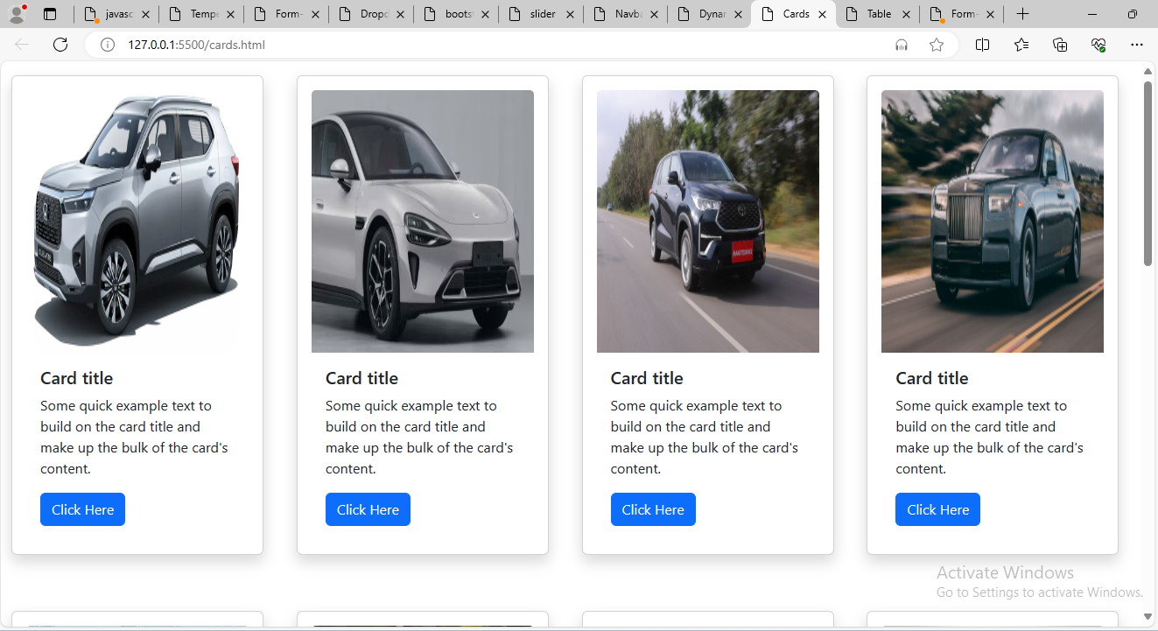

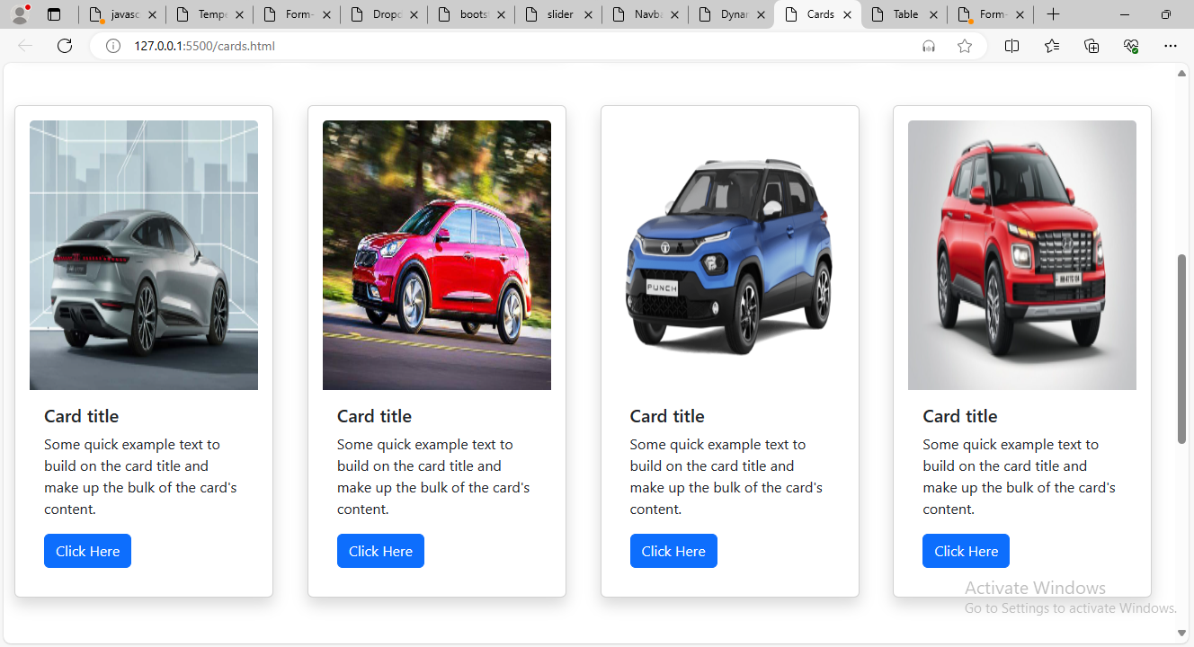

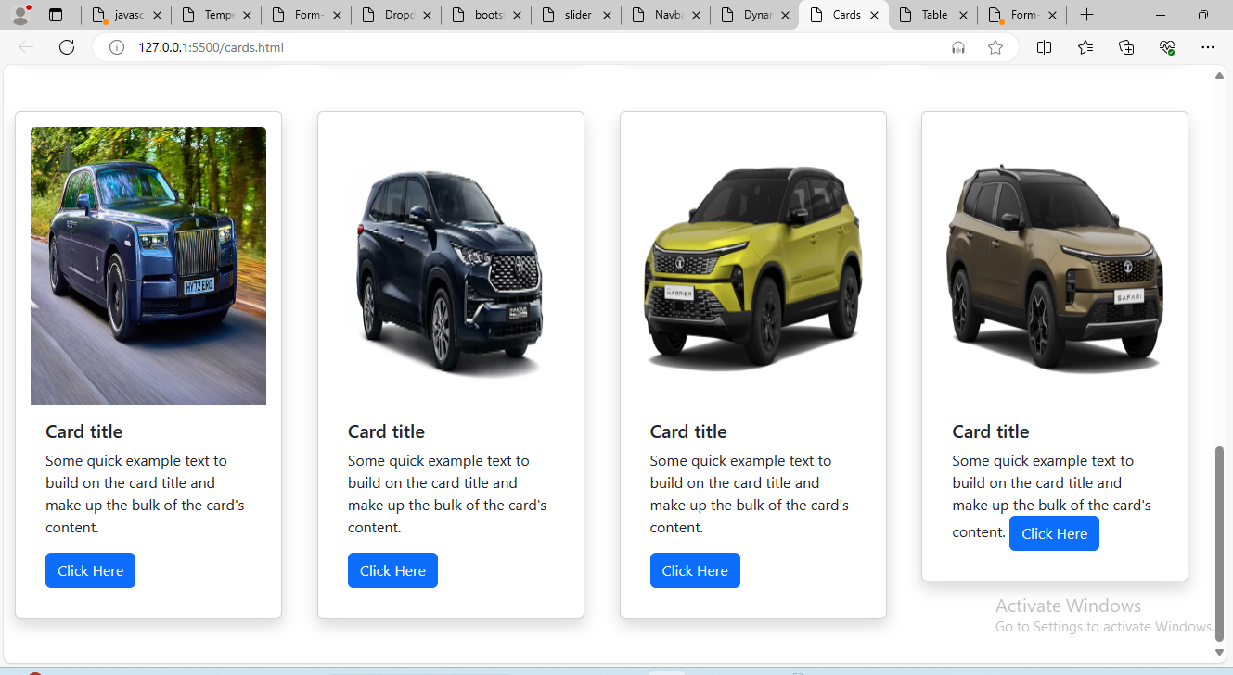

Develop a Bootstrap dropdown menu (dropdown) with multiple menu items that link to different sections or pages.

**Program:**

<!DOCTYPE html>

<html lang="en">

  <head>

    <meta charset="UTF-8" />

    <meta name="viewport" content="width=device-width, initial-scale=1.0" />

    <link

      href="https://cdn.jsdelivr.net/npm/bootstrap@5.0.2/dist/css/bootstrap.min.css"

      rel="stylesheet"

      integrity="sha384-EVSTQN3/azprG1Anm3QDgpJLIm9Nao0Yz1ztcQTwFspd3yD65VohhpuuCOmLASjC"

      crossorigin="anonymous"

    />

    <script

      src="https://cdn.jsdelivr.net/npm/@popperjs/core@2.9.2/dist/umd/popper.min.js"

      integrity="sha384-IQsoLXl5PILFhosVNubq5LC7Qb9DXgDA9i+tQ8Zj3iwWAwPtgFTxbJ8NT4GN1R8p"

      crossorigin="anonymous"

    ></script>

    <script

      src="https://cdn.jsdelivr.net/npm/bootstrap@5.0.2/dist/js/bootstrap.min.js"

      integrity="sha384-cVKIPhGWiC2Al4u+LWgxfKTRIcfu0JTxR+EQDz/bgldoEyl4H0zUF0QKbrJ0EcQF"

      crossorigin="anonymous"

    ></script>

    <link rel="stylesheet" href="dropdown.css" />

    <title>Dropdown</title>

  </head>

  <body>

    <div class="container dropdown-list">

      <div class="dropdown">

        <button

          class="btn btn-danger dropdown-toggle px-5"

          type="button"

          id="dropdownMenuButton1"

          data-bs-toggle="dropdown"

          aria-expanded="false"

        >

          Select the food item

        </button>

        <ul class="dropdown-menu p-5" aria-labelledby="dropdownMenuButton1">

          <li><a class="dropdown-item" href="#">Biriyani</a></li>

          <li><a class="dropdown-item" href="#">Panipuri</a></li>

          <li><a class="dropdown-item" href="#">Chicken curry</a></li>

          <li><a class="dropdown-item" href="#">Mutton curry</a></li>

          <li><a class="dropdown-item" href="#">Fish fry</a></li>

          <li><a class="dropdown-item" href="#">Sambar rice</a></li>

        </ul>

      </div>

    </div>

  </body>

</html>

**Output:**

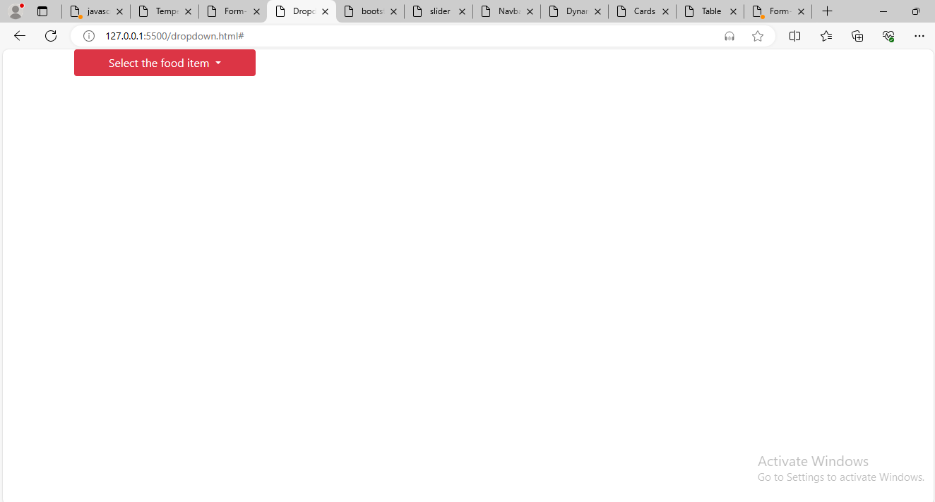

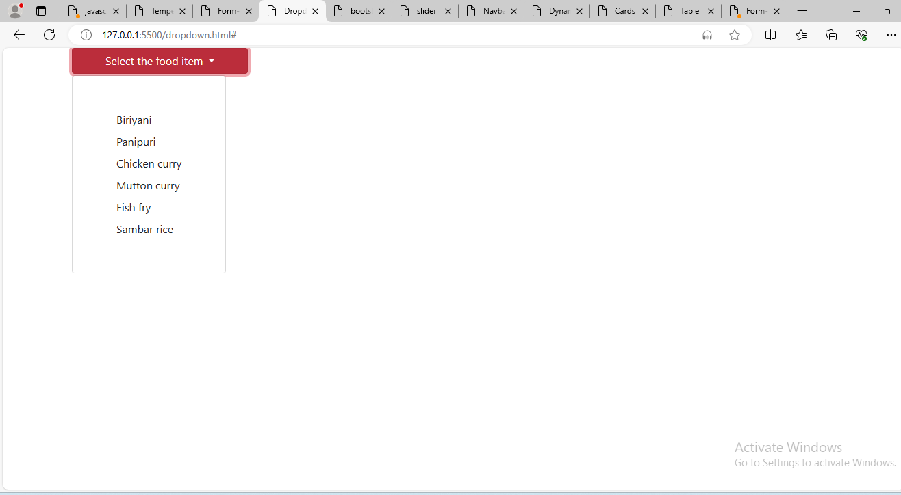

Build a responsive table using Bootstrap (table and table-responsive) to display tabular data.

**Program:**

<!DOCTYPE html>

<html lang="en">

  <head>

    <meta charset="UTF-8" />

    <meta name="viewport" content="width=device-width, initial-scale=1.0" />

    <link

      href="https://cdn.jsdelivr.net/npm/bootstrap@5.0.2/dist/css/bootstrap.min.css"

      rel="stylesheet"

      integrity="sha384-EVSTQN3/azprG1Anm3QDgpJLIm9Nao0Yz1ztcQTwFspd3yD65VohhpuuCOmLASjC"

      crossorigin="anonymous"

    />

    <script

      src="https://cdn.jsdelivr.net/npm/@popperjs/core@2.9.2/dist/umd/popper.min.js"

      integrity="sha384-IQsoLXl5PILFhosVNubq5LC7Qb9DXgDA9i+tQ8Zj3iwWAwPtgFTxbJ8NT4GN1R8p"

      crossorigin="anonymous"

    ></script>

    <script

      src="https://cdn.jsdelivr.net/npm/bootstrap@5.0.2/dist/js/bootstrap.min.js"

      integrity="sha384-cVKIPhGWiC2Al4u+LWgxfKTRIcfu0JTxR+EQDz/bgldoEyl4H0zUF0QKbrJ0EcQF"

      crossorigin="anonymous"

    ></script>

    <link rel="stylesheet" href="table.css" />

    <title>Table</title>

  </head>

  <body>

    <div class="data-table">

      <div class="container">

        <table

          class="table table-hover table-danger table-striped table-bordered border-info shadow p-3 mb-5 bg-body rounded"

        >

          <thead>

            <tr>

              <th scope="col">S.No</th>

              <th scope="col">First Name</th>

              <th scope="col">Id Num</th>

              <th scope="col">Package</th>

            </tr>

          </thead>

          <tbody>

            <tr>

              <th scope="row">1</th>

              <td>Raja shekar</td>

              <td>4512</td>

              <td>12lpa</td>

            </tr>

            <tr>

              <th scope="row">2</th>

              <td>Sharvani.p</td>

              <td>4523</td>

              <td>11lpa</td>

            </tr>

            <tr>

              <th scope="row">3</th>

              <td>Swetha.K</td>

              <td>4524</td>

              <td>10lpa</td>

            </tr>

          </tbody>

        </table>

      </div>

    </div>

  </body>

</html>

**Output:**

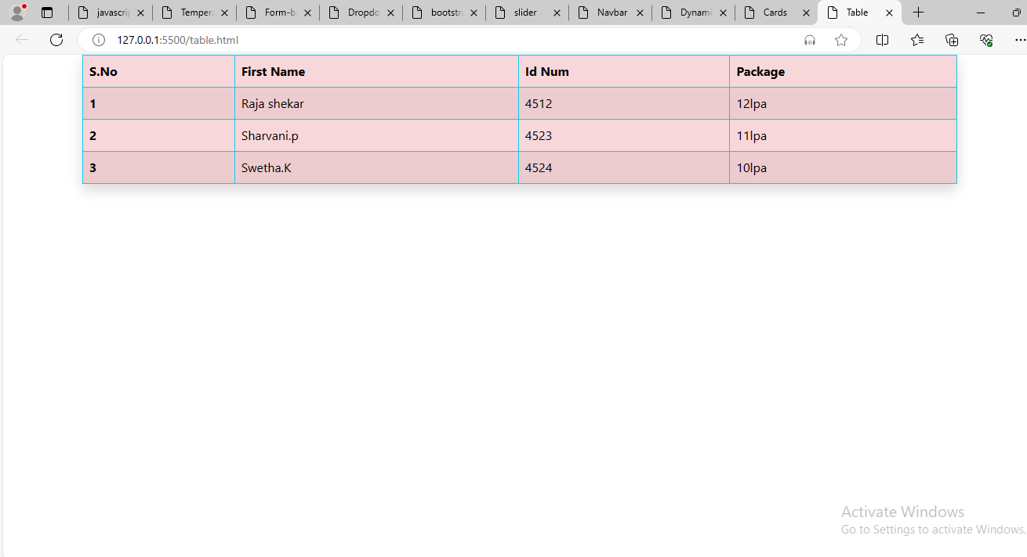

Design a Bootstrap carousel (carousel) with multiple slides/images that automatically cycle through.

**Program:**

<!DOCTYPE html>

<html lang="en">

  <head>

    <meta charset="UTF-8" />

    <meta name="viewport" content="width=device-width, initial-scale=1.0" />

    <link

      href="https://cdn.jsdelivr.net/npm/bootstrap@5.3.3/dist/css/bootstrap.min.css"

      rel="stylesheet"

      integrity="sha384-QWTKZyjpPEjISv5WaRU9OFeRpok6YctnYmDr5pNlyT2bRjXh0JMhjY6hW+ALEwIH"

      crossorigin="anonymous"

    />

    <script

      src="https://cdn.jsdelivr.net/npm/@popperjs/core@2.9.2/dist/umd/popper.min.js"

      integrity="sha384-IQsoLXl5PILFhosVNubq5LC7Qb9DXgDA9i+tQ8Zj3iwWAwPtgFTxbJ8NT4GN1R8p"

      crossorigin="anonymous"

    ></script>

    <script

      src="https://cdn.jsdelivr.net/npm/bootstrap@5.0.2/dist/js/bootstrap.min.js"

      integrity="sha384-cVKIPhGWiC2Al4u+LWgxfKTRIcfu0JTxR+EQDz/bgldoEyl4H0zUF0QKbrJ0EcQF"

      crossorigin="anonymous"

    ></script>

    <link rel="stylesheet" href="slider.css" />

    <title>slider</title>

  </head>

  <body>

    <div

      id="carouselExampleControls"

      class="carousel slide"

      data-bs-ride="carousel"

    >

      <div class="carousel-inner">

        <div class="carousel-item active">

          <img

            src="burger1.webp"

            class="d-block w-100"

            style="height: 100vh"

            alt="burger"

          />

        </div>

        <div class="carousel-item">

          <img

            src="pancake.jpg"

            class="d-block w-100"

            style="height: 100vh"

            alt="pancake"

          />

        </div>

        <div class="carousel-item">

          <img

            src="donut.avif"

            class="d-block w-100"

            style="height: 100vh"

            alt="donut"

          />

        </div>

        <div class="carousel-item">

          <img

            src="kfc.jpg"

            class="d-block w-100"

            style="height: 100vh"

            alt="chicken"

          />

        </div>

        <div class="carousel-item">

          <img

            src="main.jpg"

            class="d-block w-100"

            style="height: 100vh"

            alt="Main table"

          />

        </div>

      </div>

      <button

        class="carousel-control-prev"

        type="button"

        data-bs-target="#carouselExampleControls"

        data-bs-slide="prev"

      >

        <span class="carousel-control-prev-icon" aria-hidden="true"></span>

        <span class="visually-hidden">Previous</span>

      </button>

      <button

        class="carousel-control-next"

        type="button"

        data-bs-target="#carouselExampleControls"

        data-bs-slide="next"

      >

        <span class="carousel-control-next-icon" aria-hidden="true"></span>

        <span class="visually-hidden">Next</span>

      </button>

    </div>

  </body>

</html>

**Output:**

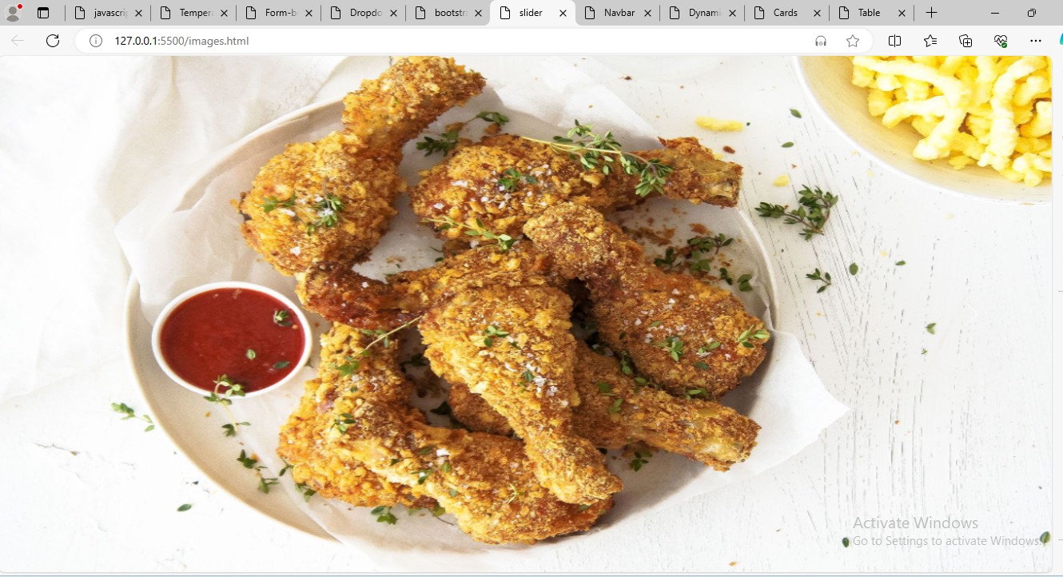

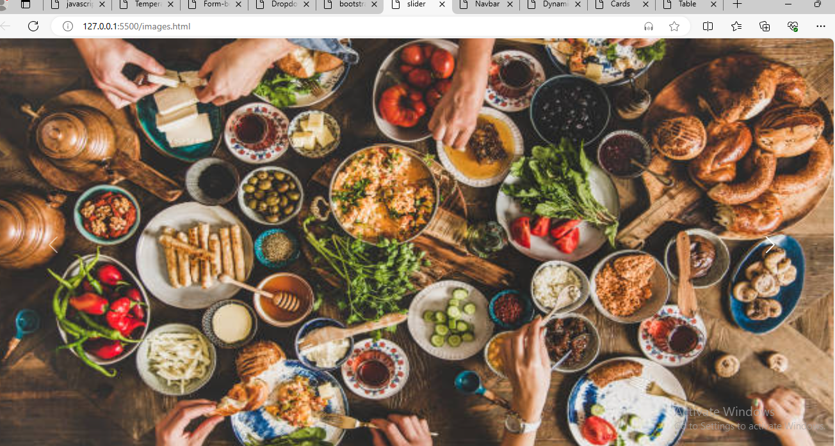

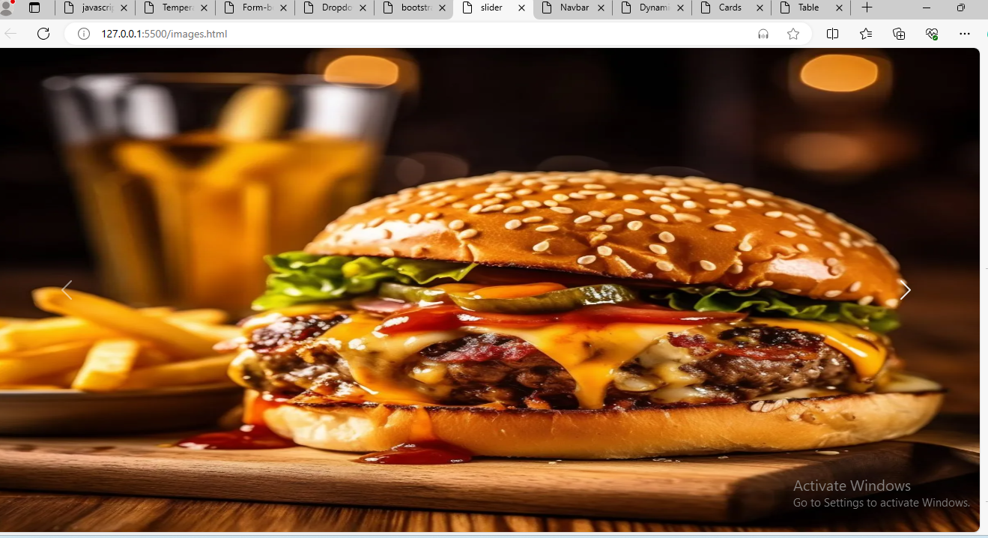

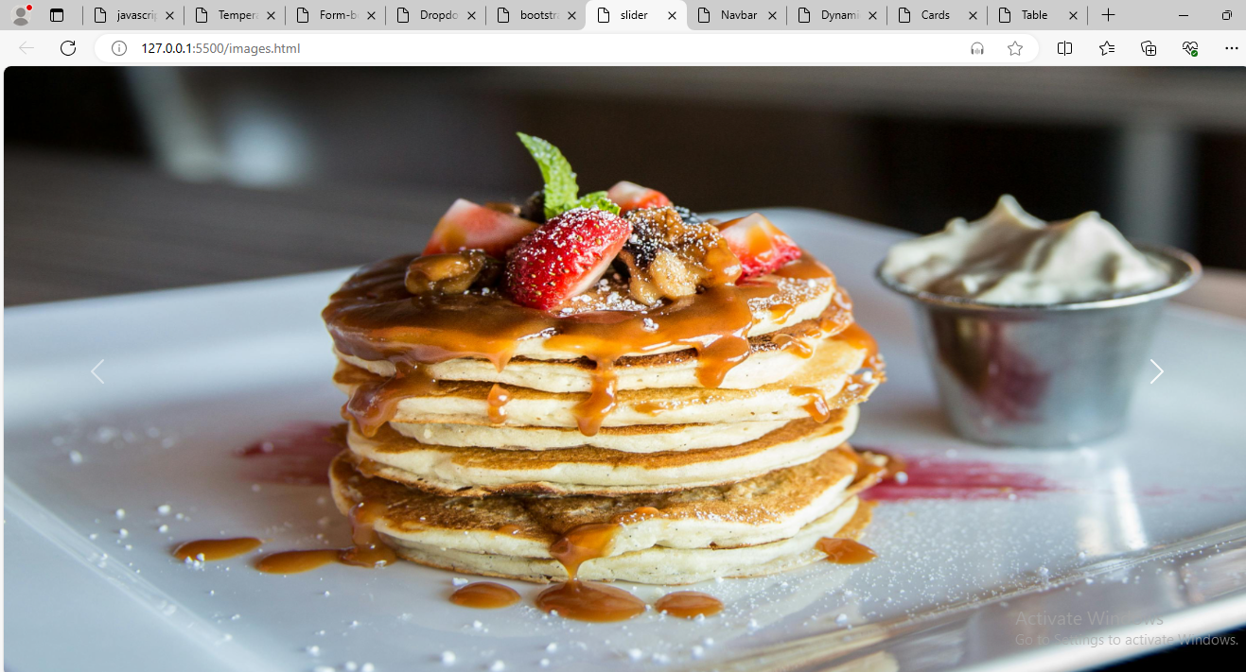

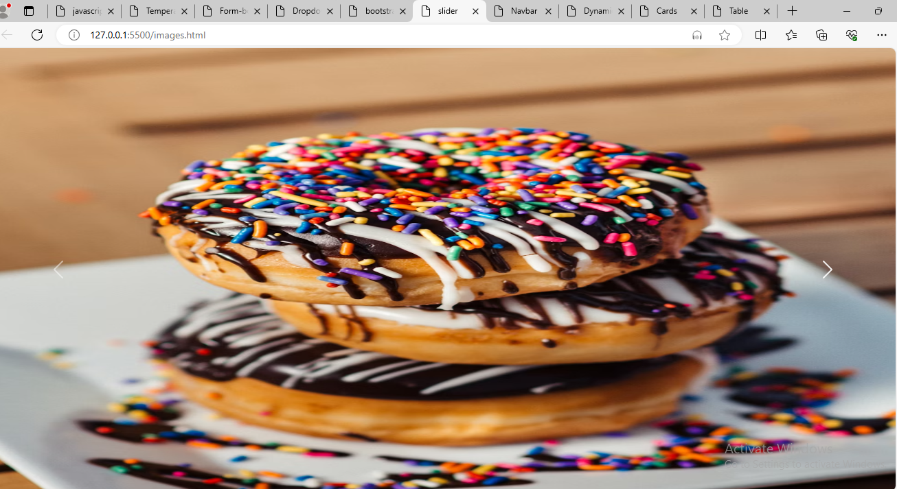

Combine JavaScript and Bootstrap to create a dynamic webpage that updates content based on user interactions (e.g., show/hide elements, change styles).

**Program:**

<!DOCTYPE html>

<html lang="en">

  <head>

    <meta charset="UTF-8" />

    <meta name="viewport" content="width=device-width, initial-scale=1.0" />

    <title>Dynamic Webpage</title>

    <link

      href="https://stackpath.bootstrapcdn.com/bootstrap/4.5.2/css/bootstrap.min.css"

      rel="stylesheet"

    />

    <script src="https://code.jquery.com/jquery-3.5.1.slim.min.js"></script>

    <script src="https://cdn.jsdelivr.net/npm/@popperjs/core@2.5.4/dist/umd/popper.min.js"></script>

    <script src="https://stackpath.bootstrapcdn.com/bootstrap/4.5.2/js/bootstrap.min.js"></script>

    <link rel="stylesheet" href="additional.css" />

  </head>

  <body>

    <div class="container mt-5">

      <h1>Web page (by:sharvani)</h1>

      <button id="toggleButton" class="btn btn-primary">Content button</button>

      <p id="contentParagraph" class="mt-3">

        Lorem ipsum, dolor sit amet consectetur adipisicing elit. Dolore veniam

        eaque laudantium pariatur atque cum dolorem natus labore voluptatem

        maxime quod, modi temporibus, excepturi, debitis nam ad? Harum, facere

        amet. Lorem ipsum dolor sit amet consectetur adipisicing elit. Soluta error pariatur non harum facilis culpa quae mollitia! Earum velit ratione nulla facere voluptas, harum ad vitae impedit iusto repudiandae quis?

        Lorem ipsum dolor sit amet consectetur adipisicing elit. Ea, necessitatibus? Nemo vero voluptatibus dicta eligendi quaerat pariatur? Autem dignissimos voluptatibus, veniam modi quia recusandae ex, ad facilis rerum ratione quae?

      </p>

    </div>

    <script>

        document.getElementById("toggleButton").addEventListener("click", function () {

  var contentParagraph = document.getElementById("contentParagraph");

  if (contentParagraph.style.display === "none") {

    contentParagraph.style.display = "block";

  } else {

    contentParagraph.style.display = "none";

  }

});

    </script>

  </body>

</html>

**Output:**

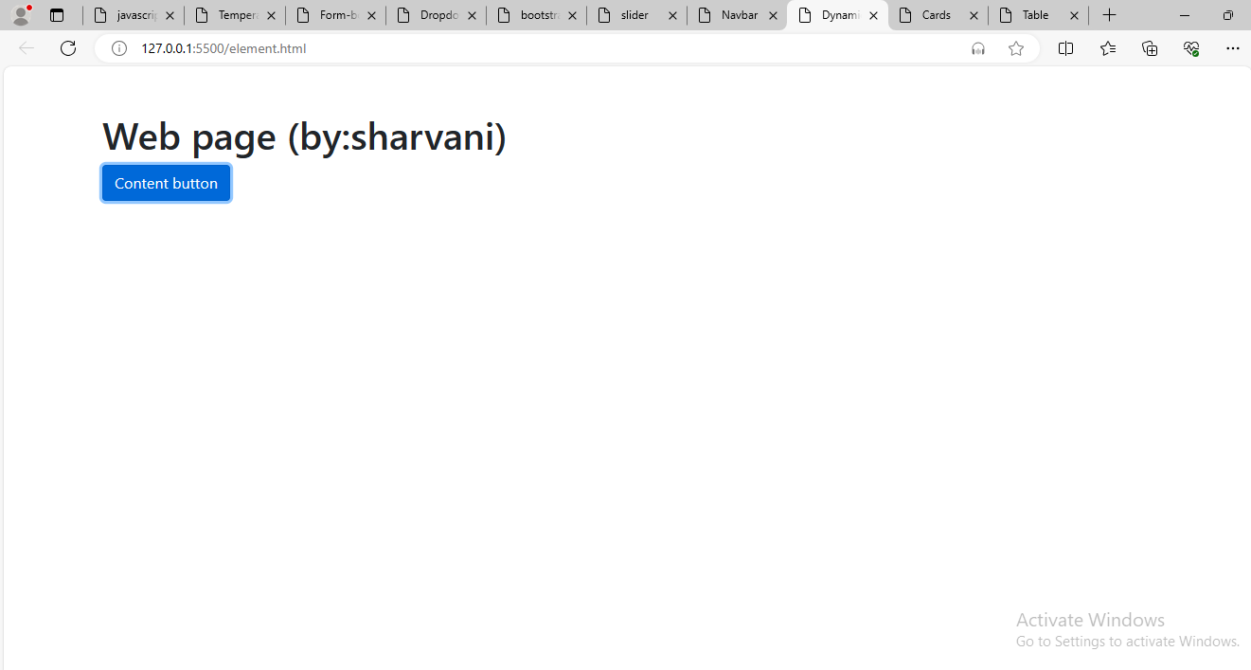

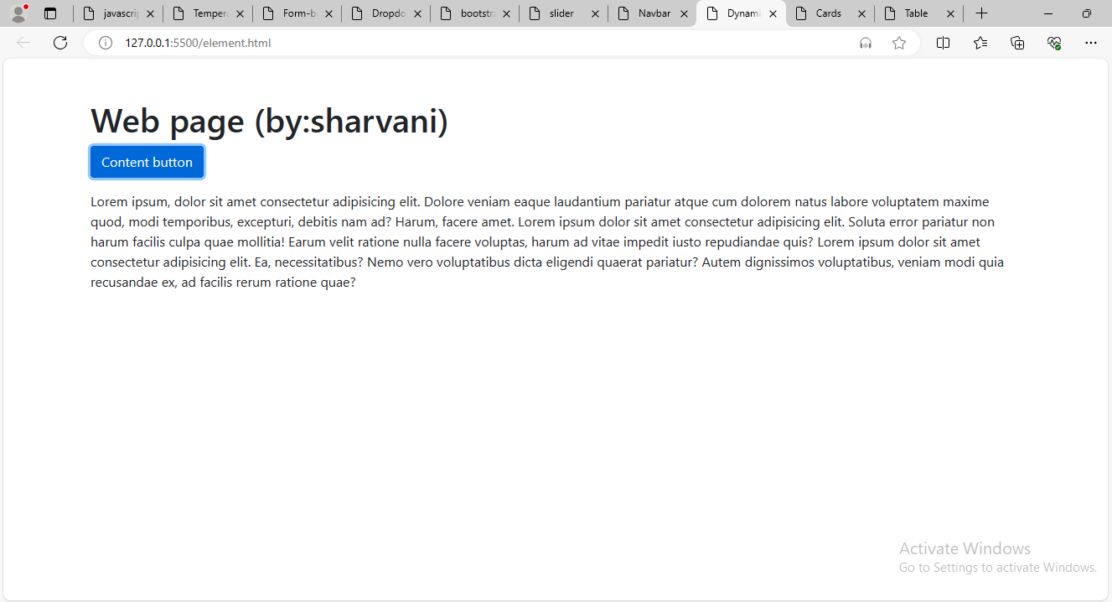

These exercises will help you practice JavaScript fundamentals an